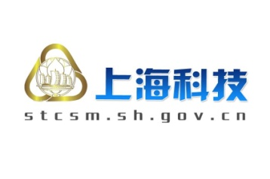
Shanghai-Singapore Joint Innovation Call
上海-新加坡产业创新合作计划项目

for Shanghai companies only（上海企业填写）

Partner Search Form合作需求信息表

1. Company Details单位信息

1.1 Organization Name单位名称
Full Name公司的全名
Stage  企业发展所处阶段 | Seed  种子期 | R&D  研发期 | Initial Revenues  初始收入期 | Revenue Growth  收入增长期
Type of Organization  公司的类型 | SME Large company Other  中小企业 大型企业 其它

1.2 Organization Address单位地址
Street路名及号码
Zip or Postal Code邮编 |  | City城市
Country国家

1.3 Contact Person Data联系人信息
Name姓名
Position职务
Direct phone Number and Mobile Number办公室电话和手机
E-mail电子信箱

1.4. Website单位网址

1.5 Organization Background 单位背景
Year Established
成立年份
No. of Employees  员工数目 |  | No. of R&D Personnel  研发人员数目
General Information
总体情况
Core Business & Area of Expertise
核心产业或专业领域
Main Products / Services
主要产品和服务
Comments
其它建议

2.Potential Project Partner/Company 意向合作单位/公司

2.1 Main Technological Area 主要技术领域

2.2 What types of partnership are you seeking? 意向寻找何种类型的合作单位？

2.3 What are the main characteristics, technological expertise, and R&D contributions you are seeking in a potential partner? 希望合作单位具备哪些条件（技术专长、研发能力等）？

2.4 Companies/Organization you are already in contact已经有意向的合作单位

3. Statement of Cooperation 合作声明
I hereby provide my consent to disclose this form to third parties in the process of identifying potential partners for the proposed project我方同意在寻找合作单位的过程中向第三方公开本表格中所填写的相关信息。

Organization Name
公司名称
Last  Name姓 |  | First Name  名
Signature
签字（电子版请手写签字后将扫描件和word原件一并通过电子邮件方式提交）

